Chapter 25 Gypsum Panel Products and Plaster
CALIFORNIA BUILDING CODE — MATRIX ADOPTION TABLE
CHAPTER 25 — GYPSUM PANEL PRODUCTS AND PLASTER
(Matrix Adoption Tables are nonregulatory, intended only as an aid to the code user.
See Chapter 1 for state agency authority and building applications.)
Adopting agency | BSC | BSC-  CG | SFM | HCD |  |  | DSA |  |  | OSHPD |  |  |  |  |  |  | BSCC | DPH | AGR | DWR | CEC | CA | SL | SLC
 |  |  |  | 1 | 2 | 1/AC | AC | SS | SS/CC | 1 | 1R | 2 | 3 | 4 | 5 | 6
Adopt entire chapter | X |  |  | X | X |  |  |  |  |  |  |  | X |  |  | X
Adopt entire chapter as amended (amended sections listed below) |  |  |  |  |  |  |  | X | X | X | X | X |  | X | X
Adopt only those sections that are listed below |  |  |  |  |  |  |  |  |  |  |  |  |  |  |  |  |  |  |  | X
Chapter / Section
2501.1.1 |  |  |  |  |  |  |  | X | X | X | X | X |  | X | X
2501.1.2 |  |  |  |  |  |  |  | X | X | X | X | X |  | X | X
2501.1.3 |  |  |  |  |  |  |  | X | X | X | X | X |  | X | X
2503.2 |  |  |  |  |  |  |  | X | X | X | X | X |  | X | X
2503.2, Exception |  |  |  |  |  |  |  |  |  |  |  | X
2504.2 |  |  |  |  |  |  |  | X | X | X | X | X |  | X | X
2504.2.1, Exception |  |  |  |  |  |  |  |  |  |  |  | X
2505.3 |  |  |  |  |  |  |  | X | X | X | X | X |  | X | X
2505.3, Exception |  |  |  |  |  |  |  |  |  |  |  | X
2507.3 |  |  |  |  |  |  |  | X | X | X | X | X |  | X | X
2507.3, Exception |  |  |  |  |  |  |  |  |  |  |  | X
2508.6.6 |  |  |  |  |  |  |  | X | X | X | X | X |  | X | X
2508.6.6, Exception |  |  |  |  |  |  |  |  |  |  |  | X
2510.6.3 |  |  |  |  |  |  |  |  |  |  |  |  |  |  |  |  |  |  |  | X
2514.1, Exception |  |  |  |  |  |  |  | X |  | X | X | X |  | X | X
The state agency does not adopt sections identified with the following symbol: †
The Office of the State Fire Marshal's adoption of this chapter or individual sections is applicable to structures regulated by other state agencies pursuant to Section 1.11.
User notes:
About this chapter: Chapter 25 contains the provisions and referenced standards that regulate the design, construction and quality of gypsum panel products and plaster and, in addition, addresses reinforced gypsum concrete. These materials are some of the most commonly used interior and exterior finish materials in the building industry. This chapter primarily addresses quality control-related issues with regard to material specifications and installation requirements. Most products are manufactured in accordance with industry standards. The building official or inspector needs to verify that the appropriate product is used and properly installed for the intended use and location. Proper design and installation of these materials are necessary to provide weather resistance and required fire protection for both structural and nonstructural building components.
ICC code development note: Code change proposals to sections preceded by the designation [BF] will be considered by a code development committee meeting during the 2024 (Group A) Code Development Cycle. All other code change proposals to this chapter will be considered by the IBC—Structural Code Development Committee during the 2025 (Group B) Code Development Cycle.
Section 2501 General
2501.1 Scope
Provisions of this chapter shall govern the materials, design, construction and quality of gypsum panel products, lath, gypsum plaster, cement plaster and reinforced gypsum concrete.
2501.1.1 Application
[DSA-SS, DSA-SS/CC & OSHPD] The scope of application of Chapter 25 is as follows:
- Applications listed in Sections 1.10.1, 1.10.2, 1.10.4 and 1.10.5 regulated by the Department of Health Care Access and Information/Office of Statewide Hospital Planning and Development (OSHPD). These applications include hospitals, hospital buildings removed from general acute care service, skilled nursing facility buildings, intermediate care facility buildings, correctional treatment centers and acute psychiatric hospital buildings.
- Structures regulated by the Division of the State Architect—Structural Safety, which include those applications listed in Section 1.9.2.1 (DSA-SS) and 1.9.2.2 (DSA-SS/CC). These applications include public elementary and secondary schools, community colleges and state-owned or state-leased essential services buildings
2501.1.2 Amendments in This Chapter
[DSA-SS, DSA-SS/CC, OSHPD] DSA-SS, DSA-SS/CC, OSHPD adopt this chapter as amended.
- OSHPD amendments appear in this chapter preceded with the appropriate acronym, as follows:
  - [OSHPD 1] - For applications listed in Section 1.10.1.
  - [OSHPD 1R] - For applications listed in Section 1.10.1.
  - [OSHPD 2] - For applications listed in Section 1.10.2.
  - [OSHPD 4] - For applications listed in Section 1.10.4.
  - [OSHPD 5] - For applications listed in Section 1.10.5.
- Division of the State Architect - Structural Safety amendments appear in this chapter preceded by the appropriate acronym, as follows:
  - [DSA-SS] - For applications listed in Section 1.9.2.1.
  - [DSA-SS/CC] - For applications listed in Section 1.9.2.2.
2501.1.3 Additional Requirements
[DSA-SS, DSA-SS/CC and OSHPD 1, 1R, 2, 4 & 5] Details of attachment for wall and ceiling coverings which are not provided for in this code shall be detailed in the approved construction documents.
Exception: Single-story Type V skilled nursing or intermediate care facilities utilizing wood-frame or light-steel-frame construction.
2501.2 Other Materials
Other approved wall or ceiling coverings shall be permitted to be installed in accordance with the recommendations of the manufacturer and the conditions of approval.
Section 2502 Performance
2502.1 General
Lathing, plastering and gypsum panel product construction shall be done in the manner and with the materials specified in this chapter and, where required for fire protection, shall comply with the provisions of Chapter 7.
Section 2503 Inspection
2503.1 Inspection
Lath and gypsum panel products shall be inspected in accordance with Section 110.3.6.
2503.2 Additional Requirements for Inspection and Testing
[DSA-SS, DSA-SS/CC and OSHPD 1, 1R, 2, 4 & 5]
- Lath, gypsum board and gypsum panel products shall be inspected in accordance with Chapter 17A and the California Administrative Code.
- No lath, gypsum board and gypsum panel products or their attachments shall be covered or finished until it has been inspected and approved by the inspector of record and/or special inspector.
- The enforcement agency shall be permitted to require tests in accordance with Table 2506.2 to determine compliance with the provisions of this code.
- The testing of gypsum board and gypsum panel products shall conform with standards listed in Table 2506.2
Exception: [OSHPD 2] Single-story Type V skilled nursing or intermediate care facilities utilizing wood-frame or light-steel-frame construction.
Section 2504 Vertical and Horizontal Assemblies
2504.1 Scope
The following requirements shall be met where construction involves gypsum panel products or lath and plaster in vertical and horizontal assemblies.
2504.1.1 Wood Framing
Assembly
Wood supports for lath or gypsum panel products, as well as wood stripping or furring, shall be not less than 2 inches (51 mm) nominal thickness in the least dimension.
Exception: The minimum nominal dimension of wood furring strips installed over solid backing shall be not less than 1 inch by 2 inches (25 mm by 51 mm).
Assembly (1)
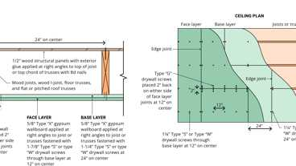
21-1.1: 1hr, Wood Joist
2504.1.2 Studless Partitions
Assembly
The minimum thickness of vertically erected studless solid plaster partitions of ³/₈-inch (9.5 mm) and ³/₄-inch (19.1 mm) rib metal lath, ¹/₂-inch-thick (12.7 mm) gypsum lath or gypsum panel product shall be 2 inches (51 mm).
Assemblies (5)
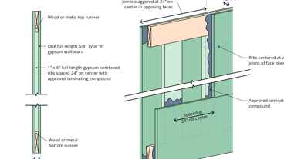Primary
10-1.1: 1hr, Studless Gyp.
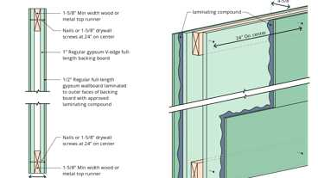Primary
10-1.2: 2hr, Studless Gyp
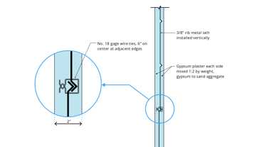Primary
6-2.3: 1hr, Solid Gyp, Studless
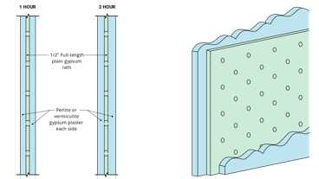Primary
6-2.2: 1hr & 2hr, Solid Gyp
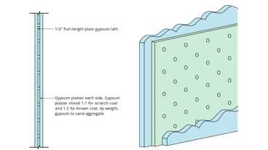Primary
6-2.1: 1hr, Solid Gyp, Studless
2504.2 Additional Requirements
[DSA-SS, DSA-SS/CC and OSHPD 1, 1R, 2, 4 & 5] In addition to the requirements of this section, the horizontal and vertical assemblies of plaster, gypsum board or gypsum panel products shall be designed to resist the loads specified in this code.
2504.2.1 Wood Furring Strips
Wood furring strips for ceilings fastened to floor or ceiling joist shall be nailed at each bearing with two common wire nails, one of which shall be a slant nail and the other a face nail, or by one nail having spirally grooved or annular grooved shanks approved by the enforcement agency for this purpose. All stripping nails shall penetrate not less than 1³/₄ inches (44.5 mm) into the member receiving the point. Holes in stripping at joints shall be subdrilled to prevent splitting.
Where common wire nails are used to support horizontal wood stripping for plaster ceilings, such stripping shall be wire tied to the joists 4 feet (1219 mm) on center with two strands of No. 18 W&M gage galvanized annealed wire to an 8d common wire nail driven into each side of the joist 2 inches (51 mm) above the bottom of the joist or to each end of a 16d common wire nail driven horizontally through the joist 2 inches (51 mm) above the bottom of the joist, and the ends of the wire secured together with three twists of the wire.
Exception: [OSHPD 2] Single-story Type V skilled nursing or intermediate care facilities utilizing wood-frame or light-steel-frame construction.
Section 2505 Shear Wall Construction
Diagram
UpCodes Diagrams (2)
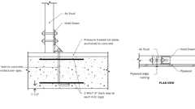Primary
Example: Shear Wall Holddown at P.T. Slab
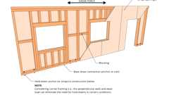
Basic Perforated Shear Wall
2505.1 Resistance to Shear (Wood Framing)
Wood-frame shear walls sheathed with gypsum panel products or lath and plaster shall be designed and constructed in accordance with Section 2306.3 and are permitted to resist wind and seismic loads. Walls resisting seismic loads shall be subject to the limitations in Section 12.2.1 of ASCE 7.
2505.2 Resistance to Shear (Steel Framing)
Cold-formed steel-frame shear walls sheathed with gypsum panel products and constructed in accordance with the materials and provisions of Section 2206.1.1 are permitted to resist wind and seismic loads. Walls resisting seismic loads shall be subject to the limitations in Section 12.2.1 of ASCE 7.
2505.3 [DSA-SS & DSA-SS/CC and OSHPD 1, 1R, 2, 4 & 5]
Section 2505.1 and 2505.2 are not permitted.
Exception: [OSHPD 2] Single-story Type V skilled nursing or intermediate care facilities utilizing wood-frame or light-steel-frame construction.
Section 2506 Gypsum Panel Product Materials
Assembly
Assemblies (3)
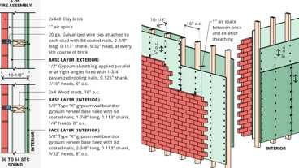
WP 8187: 2hr, 50-54 STC, Wood Studs & Brick
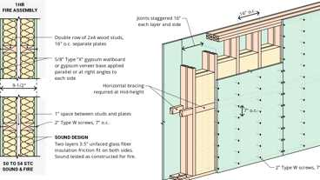
WP 3269: 1hr, 50-54 STC, Wood Studs & Insulation
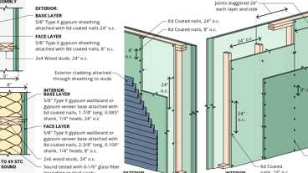
WP 8189: 2hr, 45-49 STC, Sheathing & Wood Studs
2506.1 General
Gypsum panel products and accessories shall be identified by the manufacturer's designation to indicate compliance with the appropriate standards referenced in this section and stored to protect such materials from the weather.
2506.2 Standards
Gypsum panel products shall conform to the appropriate standards listed in Table 2506.2 and Chapter 35 and, where required for fire protection, shall conform to the provisions of Chapter 7.
TABLE 2506.2—GYPSUM PANEL PRODUCTS MATERIALS AND ACCESSORIES
MATERIAL | STANDARD
Accessories for gypsum board | ASTM C1047
Adhesives for fastening gypsum board to wood framing | ASTM C557
Cold-formed steel studs and track, structural | AISI S240
Cold-formed steel studs and track, nonstructural | AISI S220
Elastomeric joint sealants | ASTM C920
Expandable foam adhesives for fastening gypsum wallboard to wood framing | ASTM D6464
Factory-laminated gypsum panel product | ASTM C1766
Fiber-reinforced gypsum panels | ASTM C1278
Glass mat gypsum backing panel | ASTM C1178
Glass mat gypsum panels | ASTM C1658
Glass mat gypsum substrate used as sheathing | ASTM C1177
Joint reinforcing tape and compound | ASTM C474; C475
Nails for gypsum boards | ASTM C514, F547, F1667
Steel screws | ASTM C954; C1002
Standard specification for gypsum board | ASTM C1396
Testing gypsum and gypsum products | ASTM C22; C472; C473
2506.2.1 Other Materials
Diagram
Metal suspension systems for acoustical and lay-in panel ceilings shall comply with ASTM C635 listed in Chapter 35 and Section 13.5.6 of ASCE 7 for installation in high seismic areas.
UpCodes Diagrams (3)
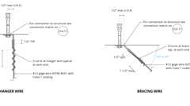Primary
Suspended Ceiling Bracing Wires
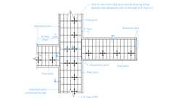
Example: Suspended Ceiling Slip Joint Plan: Corridors
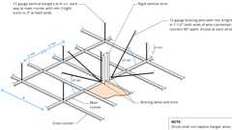
Example: Suspended Ceiling Bracing
Section 2507 Lathing and Plastering
Assembly
Assemblies (73)
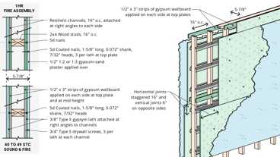
WP 3436: 1hr, 40-44 STC, Plaster/Lath & Wood Studs
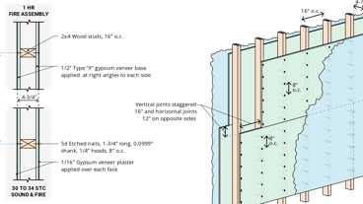
WP 3620: 1hr, 30-34 STC, Plaster & Wood Studs
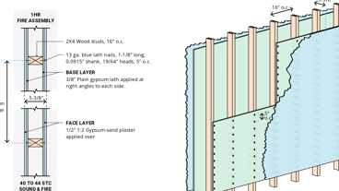
WP 3431: 1hr, 40-44 STC, Plaster/Lath & Wood Studs
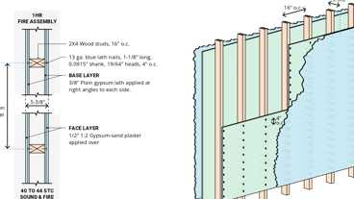
WP 3430: 1hr, 40-44 STC, Plaster/Lath & Wood Studs
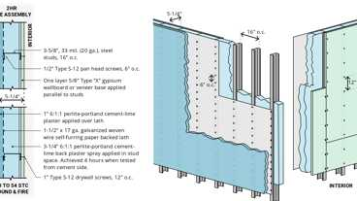
WP 8325: 2hr, Plaster/Lath & Steel Stud
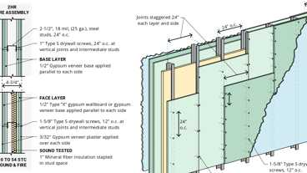
WP 1560: 2hr, 50-54 STC, Plaster & Steel Stud
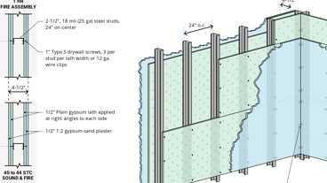
WP 1290: 1hr, 40-44 STC, Plaster/Lath & Steel Stud
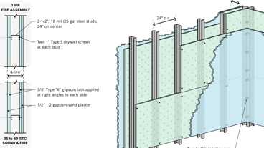
WP 1370: 1hr, 35-39 STC, Plaster/Lath & Steel Stud
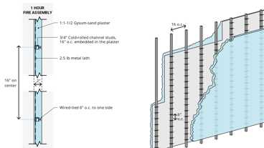
WP 1380: 1hr, 35-39 STC, Plaster/Lath & Steel Stud
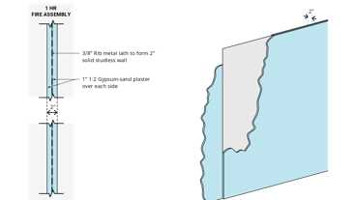
WP 1390: 1hr, 35-39 STC, Plaster/Lath
Show 63 more
2507.1 General
Lathing and plastering materials and accessories shall be marked by the manufacturer's designation to indicate compliance with the appropriate standards referenced in this section and stored in such a manner to protect them from the weather.
2507.2 Standards
Lathing and plastering materials shall conform to the standards listed in Table 2507.2 and Chapter 35 and, where required for fire protection, shall conform to the provisions of Chapter 7.
TABLE 2507.2—LATH, PLASTERING MATERIALS AND ACCESSORIES
MATERIAL | STANDARD
Accessories for gypsum veneer base | ASTM C1047
Blended cement | ASTM C595
Cold-formed steel studs and track, structural | AISI S240
Cold-formed steel studs and track, nonstructural | AISI S220
Exterior plaster bonding compounds | ASTM C932
Hydraulic cement | ASTM C1157; C1600
Gypsum casting and molding plaster | ASTM C59
Gypsum Keene's cement | ASTM C61
Gypsum plaster | ASTM C28
Gypsum veneer plaster | ASTM C587
Interior bonding compounds, gypsum | ASTM C631
Lime plasters | ASTM C5; C206
Masonry cement | ASTM C91
Metal lath | ASTM C847
Plaster aggregates
Sand | ASTM C35; C897
Perlite | ASTM C35
Vermiculite | ASTM C35
Plastic cement | ASTM C1328
Portland cement | ASTM C150
Steel screws | ASTM C1002; C954
Welded wire lath | ASTM C933
Woven wire plaster base | ASTM C1032
2507.3 Lath Attachment to Horizontal Wood Supports
[DSA-SS & DSA-SS/CC and OSHPD 1, 1R, 2, 4 & 5] Where interior or exterior lath is attached to horizontal wood supports, either of the following attachments shall be used in addition to the methods of attachment described in referenced standards listed in Table 2507.2.
- Secure lath to alternate supports with ties consisting of a double strand of No. 18 W & M gage galvanized annealed wire at one edge of each sheet of lath. Wire ties shall be installed not less than 3 inches (76 mm) back from the edge of each sheet and shall be looped around stripping, or attached to an 8d common wire nail driven into each side of the joist 2 inches (51 mm) above the bottom of the joist or to each end of a 16d common wire nail driven horizontally through the joist 2 inches (51 mm) above the bottom of the joist and the ends of the wire secured together with three twists of the wire.
- Secure lath to each support with ¹/₂-inch-wide (12.7 mm), 1¹/₂-inch-long (38mm) No. 9 W & M gage, ring shank, hook staple placed around a 10d common nail laid flat under the surface of the lath not more than 3 inches (76 mm) from edge of each sheet. Such staples may be placed over ribs of ³/₈-inch (9.5 mm) rib lath or over back wire of welded wire fabric or other approved lath, omitting the 10d nails. A minimum No. 8 wood screw in accordance with ANSI B18.6.1 with 1-inch minimum penetration into a wood joist shall be permitted to be used in lieu of the staples if they are installed with a 1-inch diameter washer.
Section 2508 Gypsum Construction
Assembly
Assemblies (177)
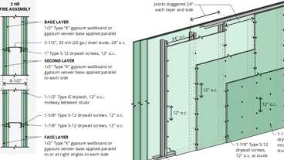
WP 1953: 2hr, Steel Stud
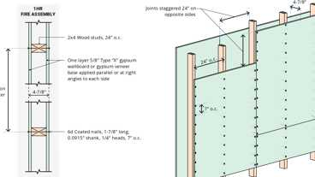
WP 3510: 1hr, Wood Studs
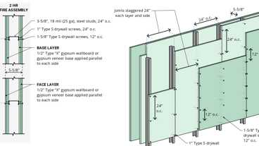
WP 1960: 2hr, Steel Stud
WP 3436: 1hr, 40-44 STC, Plaster/Lath & Wood Studs
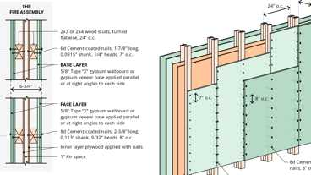
WP 3643: 1hr, Wood Studs & Plywood
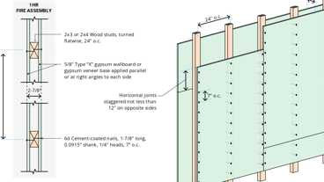
WP 3640: 1hr, Wood Studs
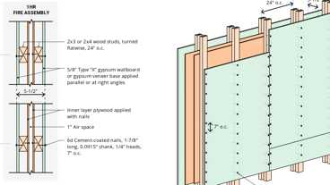
WP 3642: 1hr, Wood Studs & Plywood
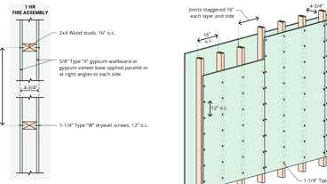
WP 3614: 1hr, Wood Studs
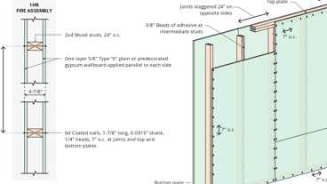
WP 3520: 1hr, Wood Studs
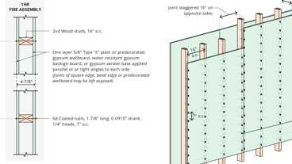
WP 3605: 1hr, Wood Studs
Show 167 more
2508.1 General
Gypsum panel products and gypsum plaster construction shall be of the materials listed in Tables 2506.2 and 2507.2. These materials shall be assembled and installed in compliance with the appropriate standards listed in Tables 2508.1 and 2511.1.1 and Chapter 35.
TABLE 2508.1—INSTALLATION OF GYPSUM CONSTRUCTION
MATERIAL | STANDARD
Gypsum panel products | GA-216; ASTM C840
Gypsum sheathing and gypsum panel products | ASTM C1280; GA-253
Gypsum veneer base | ASTM C844
Interior lathing and furring | ASTM C841
Steel framing for gypsum panel products | ASTM C754; C1007
2508.2 Limitations
Gypsum wallboard or gypsum plaster shall not be used in any exterior surface where such gypsum construction will be exposed directly to the weather. Gypsum wallboard shall not be used where there will be direct exposure to water or continuous high humidity conditions. Gypsum sheathing shall be installed on exterior surfaces in accordance with ASTM C1280 or GA-253.
2508.2.1 Weather Protection
Gypsum wallboard, gypsum lath or gypsum plaster shall not be installed until weather protection for the installation is provided.
2508.3 Single-Ply Application
Edges and ends of gypsum panel products shall occur on the framing members, except those edges and ends that are perpendicular to the framing members. Edges and ends of gypsum panel products shall be in moderate contact except in concealed spaces where fire-resistance-rated construction, shear resistance or diaphragm action is not required.
2508.3.1 Floating Angles
Fasteners at the top and bottom plates of vertical assemblies, or the edges and ends of horizontal assemblies perpendicular to supports, and at the wall line are permitted to be omitted except on shear resisting elements or fire-resistance-rated assemblies. Fasteners shall be applied in such a manner as not to fracture the face paper with the fastener head.
2508.4 Adhesives
Gypsum panel products secured to framing with adhesives in ceiling assemblies shall be attached using an approved fastening schedule. Expandable foam adhesives for fastening gypsum wallboard shall conform to ASTM D6464. Other adhesives for the installation of gypsum wallboard shall conform to ASTM C557.
2508.5 Joint Treatment
Gypsum panel product fire-resistance-rated assemblies shall have joints and fasteners treated.
Exceptions: Joint and fastener treatment need not be provided where any of the following conditions occur:
- Where the gypsum panel product is to receive a decorative finish such as wood paneling, battens, acoustical finishes or any similar application that would be equivalent to joint treatment.
- On single-layer systems where joints occur over wood framing members.
- Square edge or tongue-and-groove edge gypsum board (V-edge), gypsum panel products, gypsum backing board or gypsum sheathing.
- On multilayer systems where the joints of adjacent layers are offset.
- Assemblies tested without joint treatment.
2508.6 Horizontal Gypsum Panel Product Diaphragm Ceilings
Gypsum panel products shall be permitted to be used on wood joists to create a horizontal diaphragm ceiling in accordance with Table 2508.6.
TABLE 2508.6—SHEAR CAPACITY FOR HORIZONTAL WOOD-FRAME GYPSUM PANEL PRODUCT DIAPHRAGM CEILING ASSEMBLIES
MATERIAL | THICKNESS OF  MATERIAL  (MINIMUM) (inches) | SPACING OF  FRAMING MEMBERS  (inches) | SHEAR VALUE^{a, b}  (PLF OF CEILING) | MIMIMUM FASTENER SIZE
Gypsum panel product | ¹/₂ | 16 o.c. | 90 | 5d cooler or wallboard nail; 1⁵/₈-inch long; 0.086-inch shank; ¹⁵/₆₄-inch head^{c}
Gypsum panel product | ¹/₂ | 24 o.c. | 70 | 5d cooler or wallboard nail; 1⁵/₈-inch long; 0.086-inch shank; ¹⁵/₆₄-inch head^{c}
For SI: 1 inch = 25.4 mm, 1 pound per foot = 14.59 N/m.
- Values are not cumulative with other horizontal diaphragm values and are for short-term wind or seismic loading. Values shall be reduced 25 percent for normal loading.
- Values shall be reduced 50 percent in Seismic Design Categories D, E and F.
- 1¹/₄-inch, No. 6 Type S or W screws are permitted to be substituted for the listed nails.
2508.6.1 Diaphragm Proportions
The maximum allowable diaphragm proportions shall be 1¹/₂:1 between shear resisting elements. Rotation or cantilever conditions shall not be permitted.
2508.6.2 Installation
Gypsum panel products used in a horizontal diaphragm ceiling shall be installed perpendicular to ceiling framing members. End joints of adjacent courses of gypsum board shall not occur on the same joist.
2508.6.3 Blocking of Perimeter Edges
Perimeter edges shall be blocked using a wood member not less than 2-inch by 6-inch (51 mm by 152 mm) nominal dimension. Blocking material shall be installed flat over the top plate of the wall to provide a nailing surface not less than 2 inches (51 mm) in width for the attachment of the gypsum panel product.
2508.6.4 Fasteners
Fasteners used for the attachment of gypsum panel products to a horizontal diaphragm ceiling shall be as defined in Table 2508.6. Fasteners shall be spaced not more than 7 inches (178 mm) on center at all supports, including perimeter blocking, and not more than ³/₈ inch (9.5 mm) from the edges and ends of the gypsum panel product.
2508.6.5 Lateral Force Restrictions
Gypsum panel products shall not be used in diaphragm ceilings to resist lateral forces imposed by masonry or concrete construction.
2508.6.6 Diaphragm Ceiling Connection to Partitions
[DSA-SS & DSA-SS/CC and OSHPD 1, 1R, 2, 4 & 5] Gypsum board shall not be used in diaphragm ceilings to resist lateral forces imposed by partitions. Connection of diaphragm ceiling to the vertical lateral force resisting elements shall be designed and detailed to transfer lateral forces.
Exception: [OSHPD 2] Single-story Type V skilled nursing or intermediate care facilities utilizing wood-frame or light-steel-frame construction.
Section 2509 Showers and Water Closets
Diagram
UpCodes Diagram (1)
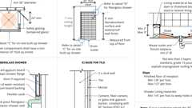
Shower Compartment (UPC)
2509.1 Wet Areas
Diagram
Showers and public toilet walls shall conform to Section 1210.2.
UpCodes Diagram (1)
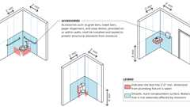
Walls and Partitions in Bathrooms and Toilet Rooms
2509.2 Base for Tile
Materials used as a base for wall tile in tub and shower areas and wall and ceiling panels in shower areas shall be of materials listed in Table 2509.2 and installed in accordance with the manufacturer's recommendations. Water-resistant gypsum backing board shall be used as a base for tile in water closet compartment walls when installed in accordance with GA-216 or ASTM C840 and the manufacturer's recommendations. Regular gypsum wallboard is permitted under tile or wall panels in other wall and ceiling areas when installed in accordance with GA 216 or ASTM C840.
TABLE 2509.2—BACKERBOARD MATERIALS
MATERIAL | STANDARD
Glass mat gypsum backing panel | ASTM C1178
Nonasbestos fiber-cement backer board | ASTM C1288 or ISO 8336, Category C
Fiber-mat reinforced cementitious backer unit | ASTM C1325
2509.3 Limitations
Water-resistant gypsum backing board shall not be used in the following locations:
- Over a vapor retarder in shower or bathtub compartments.
- Where there will be direct exposure to water or in areas subject to continuous high humidity.
Section 2510 Lathing and Furring for Cement Plaster (Stucco)
2510.1 General
Exterior and interior cement plaster and lathing shall be done with the appropriate materials listed in Table 2507.2 and Chapter 35.
2510.2 Weather Protection
Materials shall be stored in such a manner as to protect them from the weather.
2510.3 Installation
Installation of these materials shall be in compliance with ASTM C926 and ASTM C1063.
2510.4 Corrosion Resistance
Metal lath and lath attachments shall be of corrosion-resistant material.
2510.5 Backing
Backing or a lath shall provide sufficient rigidity to permit plaster applications.
2510.5.1 Support of Lath
Where lath on vertical surfaces extends between rafters or other similar projecting members, solid backing shall be installed to provide support for lath and attachments.
2510.5.2 Use of Gypsum Backing Board
Gypsum backing for cement plaster shall be in accordance with Section 2510.5.2.1 or 2510.5.2.2.
2510.5.2.1 Gypsum Board as a Backing Board
Gypsum lath or gypsum wallboard shall not be used as a backing for cement plaster.
Exception: Gypsum lath or gypsum wallboard is permitted, with a water-resistive barrier, as a backing for self-furred metal lath or self-furred wire fabric lath and cement plaster where either of the following conditions occur:
- On horizontal supports of ceilings or roof soffits.
- On interior walls.
2510.5.2.2 Gypsum Sheathing Backing
Gypsum sheathing is permitted as a backing for metal or wire fabric lath and cement plaster on walls. A water-resistive barrier shall be provided in accordance with Section 2510.6.
2510.5.3 Backing Not Required
Wire backing is not required under expanded metal lath or paperbacked wire fabric lath.
[BF] 2510.6 Water-Resistive Barriers
Water-resistive barriers shall be installed as required in Section 1403.2 and shall comply with Section 2510.6.1 or 2510.6.2.
Exception: Sections 2510.6.1 and 2510.6.2 shall not apply to construction where accumulation, condensation or freezing of moisture will not damage the materials.
[BF] 2510.6.1 Dry Climates
One of the following shall apply for dry (B) climate zones:
- The water-resistive barrier shall be two layers of 10-minute Grade D paper or have a water resistance equal to or greater than two layers of water-resistive barrier complying with ASTM E2556, Type I. The individual layers shall be installed independently such that each layer provides a separate continuous plane and any flashing, installed in accordance with Section 1404.4 and intended to drain to the water-resistive barrier, is directed between the layers.
- The water-resistive barrier shall be 60-minute Grade D paper or have a water resistance equal to or greater than one layer of water-resistive barrier complying with ASTM E2556, Type II. The water-resistive barrier shall be separated from the stucco by a layer of foam plastic insulating sheathing or other nonwater absorbing layer, or a drainage space or means of drainage complying with Section 2510.6.2. Flashing installed in accordance with Section 1404.4 and intended to drain to the water-resistive barrier shall be directed to the exterior side of the water-resistive barrier.
[BF] 2510.6.2 Moist or Marine Climates
In moist (A) or marine (C) climate zones, water-resistive barrier shall comply with one of the following:
- In addition to complying with Item 1 or 2 of Section 2510.6.1, a space or drainage material not less than ³/₁₆ inch (4.8 mm) in depth shall be applied to the exterior side of the water-resistive barrier.
- In addition to complying with Item 2 of Section 2510.6.1, drainage on the exterior side of the water-resistive barrier shall have a minimum drainage efficiency of 90 percent as measured in accordance with ASTM E2273 or Annex A2 of ASTM E2925.
2510.6.3 California Energy Code and International Energy Conservation Code Climate Zones
The IECC climate zones used by this section differ from those used by the California Energy Code to determine applicability of energy efficiency measures. Comparison of IECC andCalifornia Energy Code climate zones is shown in Chapter 12, Table 1202.3.1.
2510.7 Preparation of Masonry and Concrete
Surfaces shall be clean, free from efflorescence, sufficiently damp and rough for proper bond. If the surface is insufficiently rough, approved bonding agents or a Portland cement dash bond coat mixed in proportions of not more than two parts volume of sand to one part volume of Portland cement or plastic cement shall be applied. The dash bond coat shall be left undisturbed and shall be moist cured not less than 24 hours.
Section 2511 Interior Plaster
2511.1 General
Plastering gypsum plaster or cement plaster shall be not less than three coats where applied over metal lath or wire fabric lath and not less than two coats where applied over other bases permitted by this chapter.
Exception: Gypsum veneer plaster and cement plaster specifically designed and approved for one-coat applications.
2511.1.1 Installation
Installation of lathing and plaster materials shall conform to Table 2511.1.1 and Section 2507.
TABLE 2511.1.1—INSTALLATION OF PLASTER CONSTRUCTION
MATERIAL | STANDARD
Cement plaster | ASTM C926
Gypsum plaster | ASTM C842
Gypsum veneer plaster | ASTM C843
Interior lathing and furring (gypsum plaster) | ASTM C841
Lathing and furring (cement plaster) | ASTM C1063
Steel framing | ASTM C754; C1007
2511.2 Limitations
Plaster shall not be applied directly to fiber insulation board. Cement plaster shall not be applied directly to gypsum lath or gypsum plaster except as specified in Sections 2510.5.1 and 2510.5.2.
2511.3 Grounds
Where installed, grounds shall ensure the minimum thickness of plaster as set forth in ASTM C842 and ASTM C926. Plaster thickness shall be measured from the face of lath and other bases.
2511.4 Interior Masonry or Concrete
Condition of surfaces shall be as specified in Section 2510.7. Approved specially prepared gypsum plaster designed for application to concrete surfaces or approved acoustical plaster is permitted. The total thickness of base coat plaster applied to concrete ceilings shall be as set forth in ASTM C842 or ASTM C926. Should ceiling surfaces require more than the maximum thickness permitted in ASTM C842 or ASTM C926, metal lath or wire fabric lath shall be installed on such surfaces before plastering.
2511.5 Wet Areas
Showers and public toilet walls shall conform to Sections 1210.2 and 1210.3. Where wood frame walls and partitions are covered on the interior with cement plaster or tile of similar material and are subject to water splash, the framing shall be protected with an approved moisture barrier.
Section 2512 Exterior Plaster
Diagram
UpCodes Diagram (1)
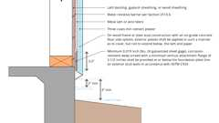
Cement Plaster: Base of Wall
2512.1 General
Plastering with cement plaster shall be not less than three coats where applied over metal lath or wire fabric lath or gypsum board backing as specified in Section 2510.5 and shall be not less than two coats where applied over masonry or concrete. If the plaster surface is to be completely covered by veneer or other facing material, or is completely concealed by another wall, plaster application need only be two coats, provided that the total thickness is as set forth in ASTM C926.
2512.1.1 On-Grade Floor Slab
On wood frame or steel stud construction with an on-grade concrete floor slab system, exterior plaster shall be applied in such a manner as to cover, but not to extend below, the lath and paper. The application of lath, paper and flashing or drip screeds shall comply with ASTM C1063.
2512.1.2 Weep Screeds
Diagram
A minimum 0.019-inch (0.48 mm) (No. 26 galvanized sheet gage), corrosion-resistant weep screed with a minimum vertical attachment flange of 3¹/₂ inches (89 mm) shall be provided at or below the foundation plate line on exterior stud walls in accordance with ASTM C926. The weep screed shall be placed not less than 4 inches (102 mm) above the earth or 2 inches (51 mm) above paved areas and be of a type that will allow trapped water to drain to the exterior of the building. The water-resistive barrier shall lap the attachment flange. The exterior lath shall cover and terminate on the attachment flange of the weep screed.
UpCodes Diagram (1)
Primary
Cement Plaster: Base of Wall
2512.2 Plasticity Agents
Only approved plasticity agents and approved amounts thereof shall be added to Portland cement or blended cements. Where plastic cement or masonry cement is used, additional lime or plasticizers shall not be added. Hydrated lime or the equivalent amount of lime putty used as a plasticizer is permitted to be added to cement plaster or cement and lime plaster in an amount not to exceed that set forth in ASTM C926.
2512.3 Limitations
Gypsum plaster shall not be used on exterior surfaces.
2512.4 Cement Plaster
Plaster coats shall be protected from freezing for a period of not less than 24 hours after set has occurred. Plaster shall be applied when the ambient temperature is higher than 40°F (4°C), unless provisions are made to keep cement plaster work above 40°F (4°C) during application and 48 hours thereafter.
2512.5 Second-Coat Application
The second coat shall be brought out to proper thickness, rodded and floated sufficiently rough to provide adequate bond for the finish coat. The second coat shall not have variations greater than ¹/₄ inch (6.4 mm) in any direction under a 5-foot (1524 mm) straight edge.
2512.6 Curing and Interval
First and second coats of cement plaster shall be applied and moist cured as set forth in ASTM C926 and Table 2512.6.
TABLE 2512.6—CEMENT PLASTERS
COAT | MINIMUM PERIOD MOIST CURING | MINIMUM INTERVAL BETWEEN COATS
First | 48 hoursª | 48 hours^{b}
Second | 48 hours | 7 days^{c}
Finish | — | Note c
- The first two coats shall be as required for the first coats of exterior plaster, except that the moist-curing time period between the first and second coats shall be not less than 24 hours. Moist curing shall not be required where job and weather conditions are favorable to the retention of moisture in the cement plaster for the required time period.
- Twenty-four-hour minimum interval between coats of interior cement plaster. For alternative method of application, see Section 2512.8.
- Finish coat plaster is permitted to be applied to interior cement plaster base coats after a 48-hour period.
2512.7 Application to Solid Backings
Where applied over gypsum backing as specified in Section 2510.5 or directly to unit masonry surfaces, the second coat is permitted to be applied as soon as the first coat has attained sufficient hardness.
2512.8 Alternate Method of Application
The second coat is permitted to be applied as soon as the first coat has attained sufficient rigidity to receive the second coat.
2512.8.1 Admixtures
Where using this method of application, calcium aluminate cement up to 15 percent of the weight of the Portland cement is permitted to be added to the mix.
2512.8.2 Curing
Curing of the first coat is permitted to be omitted and the second coat shall be cured as set forth in ASTM C926 and Table 2512.6.
2512.9 Finish Coats
Cement plaster finish coats shall be applied over base coats that have been in place for the time periods set forth in ASTM C926. The third or finish coat shall be applied with sufficient material and pressure to bond and to cover the brown coat and shall be of sufficient thickness to conceal the brown coat.
Section 2513 Exposed Aggregate Plaster
2513.1 General
Exposed natural or integrally colored aggregate is permitted to be partially embedded in a natural or colored bedding coat of cement plaster or gypsum plaster, subject to the provisions of this section.
2513.2 Aggregate
The aggregate shall be applied manually or mechanically and shall consist of marble chips, pebbles or similar durable, moderately hard (three or more on the Mohs hardness scale), nonreactive materials.
2513.3 Bedding Coat Proportions
The bedding coat for interior or exterior surfaces shall be composed of one part Portland cement and one part Type S lime; or one part blended cement and one part Type S lime; or masonry cement; or plastic cement and not more than three parts of graded white or natural sand by volume. The bedding coat for interior surfaces shall be composed of 100 pounds (45.4 kg) of neat gypsum plaster and not more than 200 pounds (90.8 kg) of graded white sand. A factory-prepared bedding coat for interior or exterior use is permitted. The bedding coat for exterior surfaces shall have a minimum compressive strength of 1,000 pounds per square inch (6895 kPa).
2513.4 Application
The bedding coat is permitted to be applied directly over the first (scratch) coat of plaster, provided that the ultimate overall thickness is not less than ⁷/₈ inch (22 mm), including lath. Over concrete or masonry surfaces, the overall thickness shall be not less than ¹/₂ inch (12.7 mm).
2513.5 Bases
Exposed aggregate plaster is permitted to be applied over concrete, masonry, cement plaster base coats or gypsum plaster base coats installed in accordance with Section 2511 or 2512.
2513.6 Preparation of Masonry and Concrete
Masonry and concrete surfaces shall be prepared in accordance with the provisions of Section 2510.7.
2513.7 Curing of Base Coats
Cement plaster base coats shall be cured in accordance with ASTM C926. Cement plaster bedding coats shall retain sufficient moisture for hydration (hardening) for 24 hours minimum or, where necessary, shall be kept damp for 24 hours by light water spraying.
Section 2514 Reinforced Gypsum Concrete
2514.1 General
Reinforced gypsum concrete shall comply with the requirements of ASTM C317 and ASTM C956.
Exception: [DSA-SS and OSHPD 1, 1R, 2, 4 & 5] Reinforced gypsum concrete shall be considered as an alternative system, except for [OSHPD 2] single-story Type V skilled nursing or intermediate care facilities utilizing wood-frame or light-steel-frame construction.
2514.2 Minimum Thickness
The minimum thickness of reinforced gypsum concrete shall be 2 inches (51 mm) except the minimum required thickness shall be reduced to 1¹/₂ inches (38 mm), provided that the following conditions are satisfied:
- The overall thickness, including the formboard, is not less than 2 inches (51 mm).
- The clear span of the gypsum concrete between supports does not exceed 33 inches (838 mm).
- Diaphragm action is not required.
- The design live load does not exceed 40 pounds per square foot (psf) (1915 Pa).

